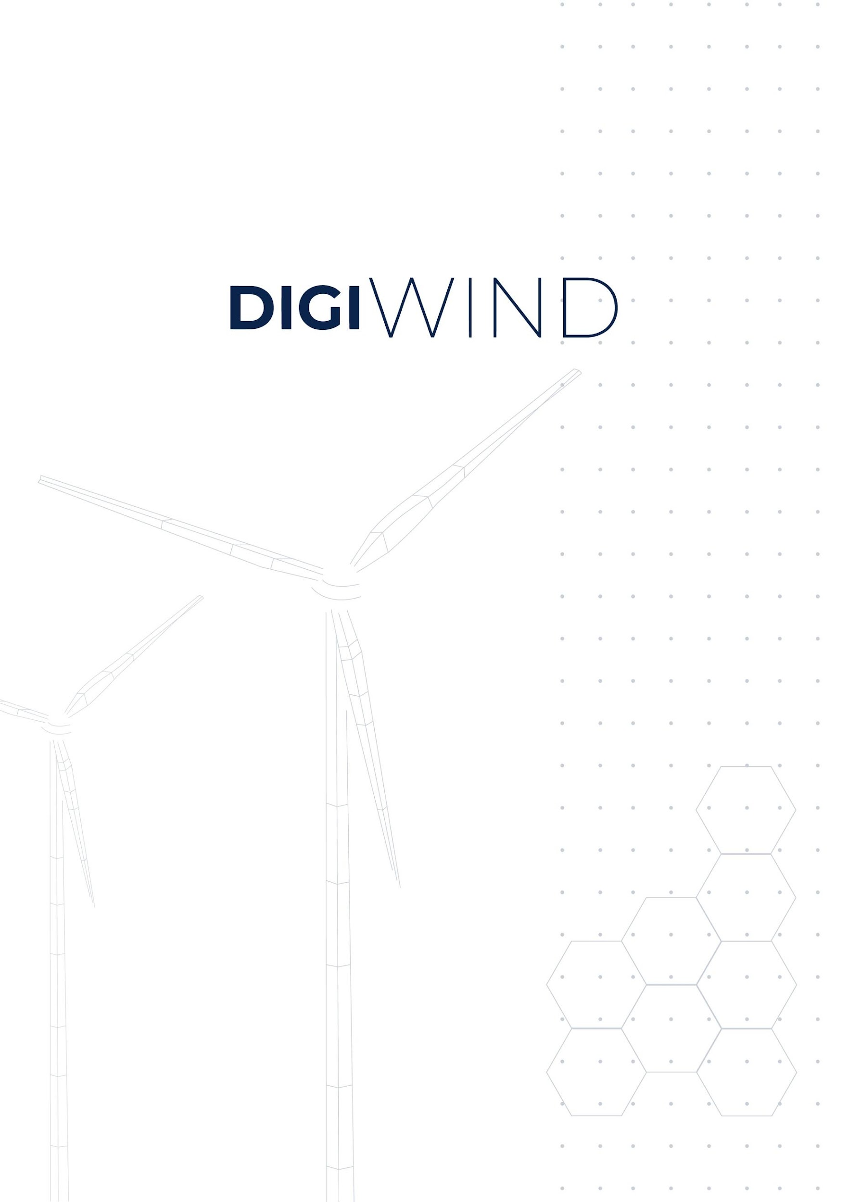

ONLINE APPLICATION FORM

Project name: Digital Masters of Wind and Energy Systems
Topic: DIGITAL-2022-SKILLS-03-SPECIALISED-EDU

Welcome! This is the online submission form for the DigiWind – TUS Summer Internship Open Call. The application form has the following mandatory sections:
SECTION 1: APPLICANT PROFILE AND PERSONAL DATA
SECTION 2: ACADEMIC QUALIFICATIONS
SECTION 3: PROFESSIONAL EXPERIENCE, KNOWLEDGE AND MOTIVATION
SECTION 4: DOCUMENTS
SECTION 5: COMMITMENT TO DIVERSITY, EQUALITY AND GENDER BALANCE
SECTION 6: REQUIREMENTS TO JOIN THE PROGRAMME

Please read the Guidelines for Applicants document thoroughly before completing this form. All information provided will be treated in accordance with the DigiWind Data Protection Policy (see F6S Privacy Policy and Project Repository details in Guidelines for applicants).
- Application Period: 22 October 2026 – 1 March 2027 (17:00 CET)
- Notification of Results: 15 March 2027
- Programme Start: 7 June 2027 (12 weeks, until 27 August 2027)

If you have any questions, don't hesitate to contact the DigiWind team at tus-opencall@digiwind.org
Failure to provide the required information in all sections will result in disqualification. Good luck!
SECTION 1: APPLICANT PROFILE AND PERSONAL DATA
Applicants are welcome who meet one of the following criteria:
Option 1 – Degree holders: applicants holding a bachelor's degree (e.g. EQF 6 / NFQ 8) or higher in a relevant engineering, computing or technology discipline. The programme is particularly suited to existing technological, electrical, mechanical, scientific or engineering professionals, and those migrating from associated disciplines.

Option 2 – Recognition of Prior Learning (RPL): applicants from other disciplines who have a minimum of five years experiential learning in related sectors (with a demonstrable knowledge of mathematics and computing). Their admission to the programme will be determined by the TUS Recognition of Prior Learning (RPL) Process.

NOTE: the Summer Internship requires mandatory in-person attendance at the TUS Campus in Limerick, Ireland, for the full 12 weeks (7 June – 27 August 2027). Stipend payments are subject to physical attendance. Only one application will be accepted per candidate.

IMPORTANT: All questions marked with a * are mandatory, however not all questions will be relevant to you. If this is the case, please select "This question is not relevant to me (I apply for other participation options)".

1 FULL LEGAL NAME *
Please provide first name and last name
2 DATE OF BIRTH * (MM/DD/YYYY)
3 NATIONALITY (AS PER PASSPORT) *
Note: Applicant must be a passport holder from an EU Member State or one of the following countries: Albania, Bosnia and Herzegovina, EEA countries (Iceland, Norway, Liechtenstein), Kosovo, Moldova, Montenegro, North Macedonia, Serbia, Türkiye or Ukraine. As per guidelines of Digital Europe Programme https://ec.europa.eu/info/funding-tenders/opportunities/docs/2021-2027/digital/guidance/list-3rd-country-participation_digital_en.pdf
4 EMAIL ADDRESS *

5 PHONE NUMBER (WITH INTERNATIONAL DIAL CODE)

6 TYPE OF APPLICANT*
Choose your participation option. Make sure to answer the correct questions in this section, according to the type of participation you have selected.
▢ Option 1 – Degree holder (bachelor's degree or higher in a relevant engineering, computing or technology discipline)
▢ Option 2 – Recognition of Prior Learning (RPL) Professional

7 EXPERIENCE *
This experience needs to be reflected on your CV. If not relevant (you selected Option 1 in question nº 8), please select This question is not relevant to me (I apply for other participation options).

▢ I confirm that I have a minimum of five years experiential learning in a relevant Wind and Energy Systems environment or related sector, with a demonstrable knowledge of mathematics and computing
▢ This question is not relevant to me (I apply for other participation options)

Programme
8 PROGRAMME AND IN-PERSON ATTENDANCE *
You are applying for the Leadership in Offshore Renewable Energy Summer Internship (10 ECTS), a 12-week programme delivered in person at the TUS Campus in Limerick, Ireland (7 June – 27 August 2027). Stipend payments are subject to physical attendance.
▢ I confirm that I am available to attend the Leadership in Offshore Renewable Energy Summer Internship in person in Limerick, Ireland, for the full 12-week duration

SECTION 2: ACADEMIC QUALIFICATIONS
HIGHEST COMPLETED DEGREE*
▢ Bachelor's degree
▢ Master's degree
▢ PhD

10 DEGREE TITLE (E.G., BSC ELECTRICAL ENGINEERING) *

11 AWARDING INSTITUTION (UNIVERSITY) *

12 FINAL GRADE/CLASSIFICATION *
Provide your final grade. If the scale used by your university is not the EQF standard, please clarify the used scale (e.g., out of 100%, 5.0, etc. - i.e 4.5/5.0)

SECTION 3: PROFESSIONAL EXPERIENCE, KNOWLEDGE AND MOTIVATION

13 MOTIVATION STATEMENT *
Explain your motivation to undertake the Leadership in Offshore Renewable Energy Summer Internship and how it links to your goals and future career in Wind and Energy Systems.

14 RELEVANT SKILLS AND EXPERIENCE *
In which of the following areas do you have skills or experience? Select all that apply.
▢ Electrical power systems
▢ Electrical controls
▢ Substation / grid operations
▢ Wind turbine technology
▢ Wind farm resource monitoring and modelling
▢ Wind farm operations and maintenance (O&M)
▢ Software programming
▢ Statistical tools
▢ None of the above

SECTION 4: DOCUMENTS
All documents must be uploaded in PDF format with no printing restrictions.

15 UPLOAD A COPY OF YOUR HIGHEST EDUCATION DEGREE (PDF ONLY) *
Original or certified copy of your highest award (Bachelor's, Master's or PhD).
16 UPLOAD YOUR ACADEMIC TRANSCRIPTS FOR YOUR HIGHEST EDUCATION DEGREE (PDF ONLY) *

17 UPLOAD YOUR CV (PDF ONLY) *
Your CV must clearly evidence your qualifications, your knowledge of renewable energy systems and any relevant professional experience.
UPLOAD CERTIFIED EVIDENCE OF ENGLISH LANGUAGE COMPETENCY (PDF ONLY)
IELTS score of 6.5 or TOEFL iBT score of 90 (with a minimum of 21 in writing and 19 in all other sections). Applicants whose native language is English are exempt from the certificate upload requirement. For all other applicants, submission of this document is mandatory.
19 UPLOAD EVIDENCE OF PROFESSIONAL EXPERIENCE – RPL APPLICANTS ONLY (PDF ONLY)
Mandatory for applicants who selected Option 2 in question nº 6: documentation proving at least five years of professional experience in a relevant Wind and Energy Systems environment (e.g. employer letters, contracts or references). Applicants who selected Option 1 do not need to upload this document.
SECTION 5: COMMITMENT TO DIVERSITY, SOCIAL AND ECONOMIC EQUALITY, AND GENDER BALANCE
20 GENDER *
▢ Male
▢ Female
▢ Non-binary
▢ Prefer not to say

21 RELEVANT INFORMATION *
Please describe in a short paragraph any relevant information demonstrating your commitment to Diversity, Social and Economic Equality and Gender balance and/or involvement in under-represented groups.

SECTION 6: REQUIREMENTS TO JOIN THE PROGRAMME

22 DIGIWIND GUIDELINES FOR APPLICANTS *
I have reviewed and ACCEPT all conditions of the DigiWind TUS Summer Internship Open Call Guidelines for Applicants, available at: [link to the TUS Summer Internship Guidelines for Applicants to be added]

23 DATA MANAGEMENT *
I ACCEPT that the information provided and submitted in this proposal can be shared by F6S with the project consortium for the purposes of managing the programme.

24 VISA AND HEALTH INSURANCE *
I UNDERSTAND that, if selected, I am responsible for obtaining any visa or residence permit required for my stay at TUS, and for ensuring I have appropriate health insurance coverage for the full duration of the internship.

25 How did you hear about the DigiWind – TUS Summer Internship Open Call? *

▢ F6S platform
▢ DigiWind website
▢ Social Media (LinkedIn)
▢ European Commission Portal
▢ DigiWind information webinar
▢ Acquaintances
▢ Events
▢ Other

