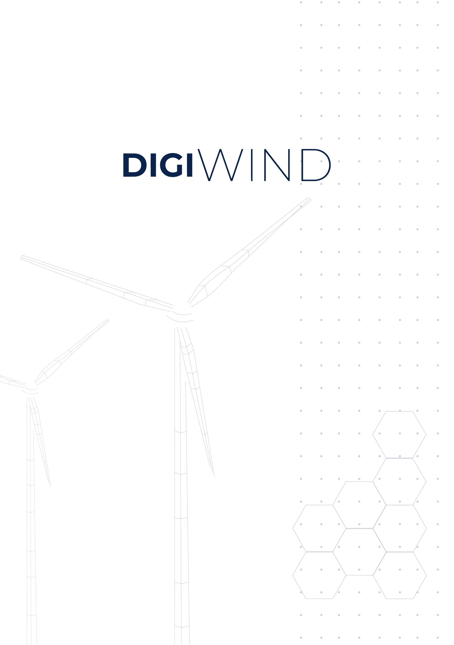
declaration of honour
Project name: Digital Masters of Wind and Energy Systems
Topic: DIGITAL-2022-SKILLS-03-SPECIALISED-EDU

beneficiary declaration of honour

Project Title: Digital Masters of Wind and Energy Systems
Proposal Acronym: DigiWind

Beneficiary full name: __________________________________________________

The candidate applying to the DigiWind TUS Open Call Summer Internship via the online submission form on the F6S platform confirms:
[1] Having read the information about the TUS Open Call described in the official Guidelines for Applicants.
[2] Agreeing to the terms and conditions included in the Guidelines for Applicants for the TUS Open Call.
[3] Agreeing with carrying out a summer internship programme at TUS (Technological University of the Shannon: Midlands).
[4] That all information provided in the online submission form on the F6S platform is up-to-date and correct.
[5] That the beneficiary is not subject to a conflict of interest.
[6] That the beneficiary has stable and sufficient sources of funding to maintain its activity throughout its participation in the above-mentioned internship.
[7] That the beneficiary has or will have the necessary resources (e.g. visa, health insurance) as and when needed to carry out its involvement in the above-mentioned programme.

Beneficiary signature

Done at (place) ______________, on the _____ (day) _____ (month) ________ (year)

